
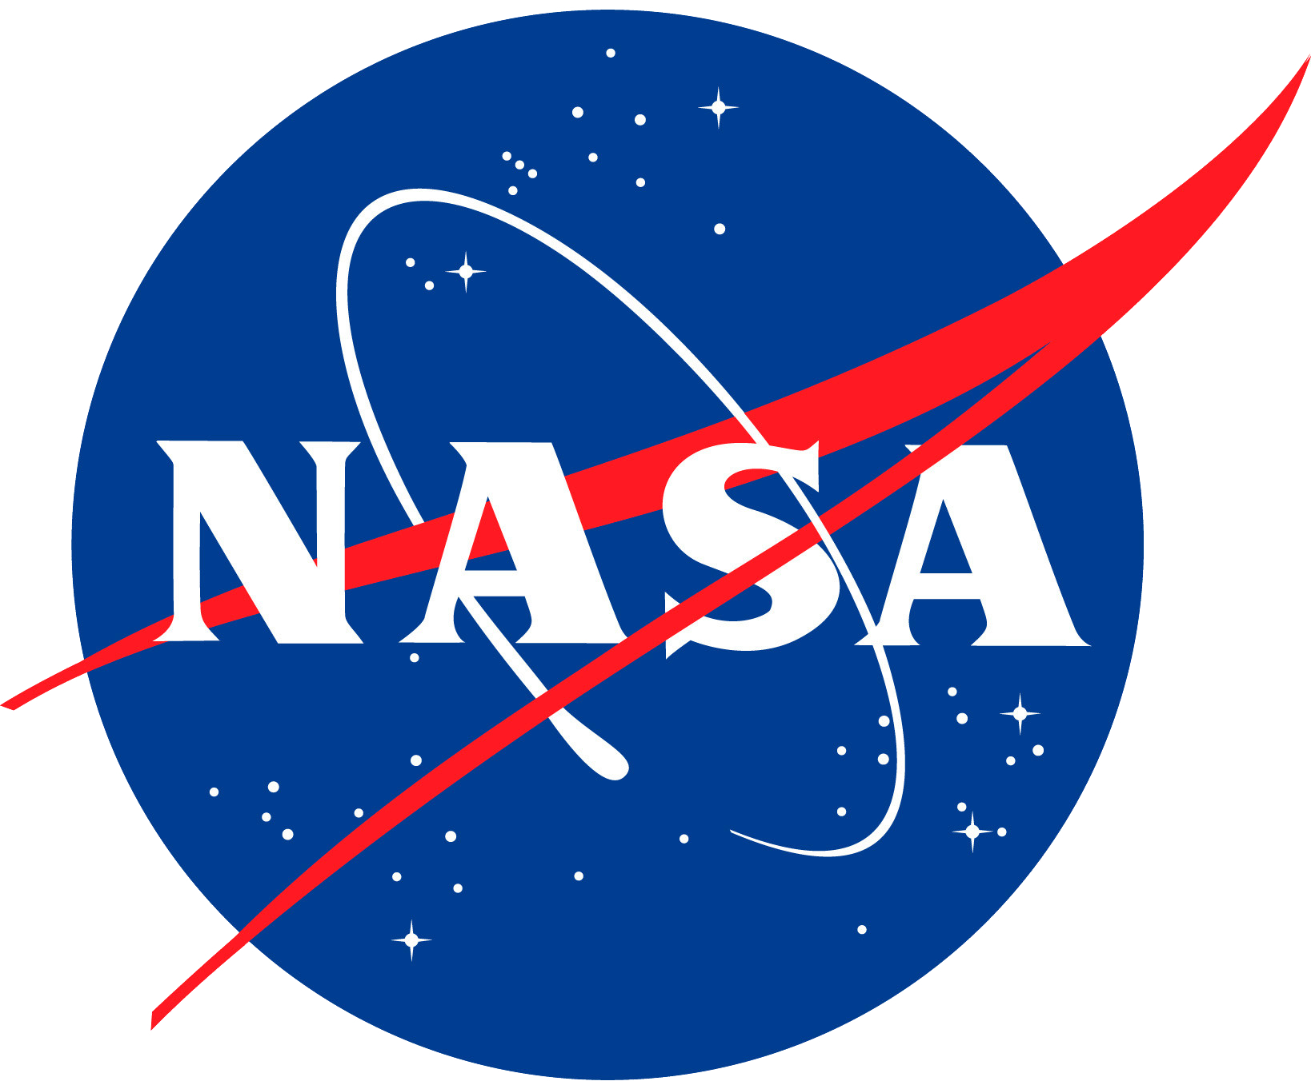
Earth Science Review Board
Onboarding Kit
Contents
Introduction 2
How does it work? 2
Participant Roles & Expectations 2
Structure of Board Review 3
Process 3
Findings & Recommendations 4
Looking Ahead 4
Appendix 5
FAQs 5
Case Review Form 6

Introduction
NASA Lifelines’ Earth Science Review Board offers humanitarian decision-makers an opportunity to engage a small group of Earth science experts and hear their feedback on how to integrate satellite data and tools into their investments and programs. By intentionally soliciting an unbiased review of their investment or program design, humanitarian funders and implementers can make the most impactful use of available technologies. In an ever-evolving landscape, access to technical geospatial expertise helps us take advantage of new trends and build on what is working while avoiding duplication of efforts.

How does it work?
Any humanitarian funder or implementer can submit a case to the review board, and the expert groups will be tailored to the needs of the case. Cases can vary in their level of depth and completeness. For example, experts could have specific domain knowledge (e.g., digital health or displacement), experience in-country or in-region, and/or have implemented a similar effort. Humanitarians will be able to select the experts from our vetted roster of interested experts. Once the group is finalized, humanitarians will share materials detailing their proposed approach and any specific questions they have for the experts. Experts will have at least two weeks, if not more, to review the materials and prepare their feedback. They will also have an opportunity to ask any clarifying questions before the board meets and can connect with the other experts in their group.

Participant Roles & Expectations
Case Sponsors – these are humanitarian funders or implementers who bring forward an investment or program design for review. Sponsors will need to compile and share materials that will provide enough detail while not overwhelming experts with excessive reading. Sponsors are not expected to adopt any of the recommendations from the review board. The time commitment is likely a couple hours to share the materials, participate in the board meeting, and receive recommendations.
Experts – these are individuals who have training and/or experiences using satellite data and tools (even better if that experience includes using these data and tools for humanitarian outcomes) and are volunteering their time to provide guidance that will make a difference. Experts will need to review all materials provided and come prepared to discuss and provide thoughtful feedback. They are also expected to raise any potential conflicts of interest and recuse themselves from specific cases, if needed. The time commitment is likely three hours to review materials and prepare feedback in the case review form, and participate in the board meeting.
Moderator – from the Lifelines Team, this individual will moderate the discussion and be responsible for coordinating the review, consolidating expert recommendations, and following up with the case sponsor.
To best support our community and the review boards specifically, the NASA Lifelines team will reach out to the wide spectrum of experts to build our roster and ensure relevant experts are interested and available. This means curating a diverse pool of experts spanning different disciplines, geographies, sectors, and backgrounds. The NASA Lifelines team will also vet interested experts and steward the connections between sponsors and experts through our website and automated tools.

Structure of Board Review
The board meeting will be an hour and a half. The sponsor and experts will be in attendance for a discussion of the case material. Experts will have a chance to share their feedback and discuss with each other, as well as ask any clarifying questions of the sponsor. Sponsors will mostly be in listening mode. The last half hour will see the experts sharing their final recommendations with the sponsor.

Process
- Interested experts can sign up for the Earth Science Review Board and complete their profile in the NASA Lifelines website to highlight their backgrounds and experiences.
- Interested sponsors submit their case via the NASA Lifelines website.
- Experts can express their interest in supporting a specific case.
- From the shortlist of interested experts (up to 8 experts), sponsors select four to five whose backgrounds best meet their needs.
- Experts are invited to participate and once they accept, they receive the case materials. Experts have two weeks to review materials and prepare for the board meeting.
- Experts join the board meeting prepared to discuss with each having filled out the case review form. Sponsors join the board meeting ready to listen.
- At the end of the board meeting, the experts give their final recommendations and the moderator gathers the case review form and meeting transcript to generate a recommendation summary.
- Moderator submits the recommendation summary to the sponsor and NASA Lifelines team.
- The NASA Lifelines team pulls out high-level takeaways that can be shared with the broader community.

Findings & Recommendations
Experts are asked to provide thoughtful and detailed feedback to sponsors with the goal of making their proposed approach more impactful. This could include lessons learned from similar approaches, relevant third-party resources, context-specific considerations, potential risks, or other feedback. These findings and collated recommendations will be synthesized into the review form.

Looking Ahead
The Earth Science Review Board will meet virtually on a rolling basis.

Appendix

FAQs

What does the board review?
Case sponsors provide documents and/or a presentation for experts to review.

What kinds of cases does the board review?
Any investment, program, and/or use case using satellite data and tools are good candidates for the Earth Science Review Board.

Do cases need to have a satellite data component?
Yes, or at least aspire to have a satellite data component.

Do cases need to have a humanitarian focus?
Yes, every case needs to have a humanitarian focus, which we define broadly as any intervention that reduces human suffering.

Who are our experts?
NASA Lifelines is a global community comprised of interdisciplinary experts who use satellite data and tools for humanitarian action.

How do we vet the roster of experts?
Through the NASA Lifelines website, experts are required to fill out a profile to get connected into the ESRB opportunities. This profile will have information from their LinkedIn profiles, education, experiences, current role and organization, areas of expertise, geographic focus, and the like.

When will review boards be happening?
The Earth Science Review Board will meet virtually on a rolling basis except for select in-person conferences

What if the interested experts do not have the kinds of expertise required for the specific case?
The NASA Lifelines team is focused on building a robust, global roster of experts with varied expertise. If a sponsor brings forward a case that requires certain expertise not yet found within our community, the NASA Lifelines team will make a concerted effort to identify folks who could support.

What happens if I have a conflict of interest with a case?
As part of the selection process, experts will be asked if they have any potential conflicts of interest so we can minimize any bias or issues.

Case Review Form
Earth Science Review Board (ESRB) Case Review Form
Case Overview
- Case Name:
- Sponsor Name:
- Experts Reviewing (Names and Affiliations):
- Would you like your contact information to be shared with the case sponsor for potential follow-ups?

Please provide a summary (three to five sentences) of the case you reviewed, highlighting its main objectives and approaches. Be sure to consider the stated goals of the humanitarian and what areas your feedback would be most helpful. Consider aspects like innovation, use of Earth Science, alignment with humanitarian goals, technical approach, scalability, sustainability (including return on investment), and context-specific considerations.

Strengths of the Case: What are the key strengths of the program or initiative presented in this case?

Areas for Improvement: What areas of the program or initiative could be improved? Consider the same aspects as given above.

Recommended Resources: What are some specific tools, models, data, techniques, and approaches that should be considered alongside or in lieu of the current approach?
- Name of Resource:
- Resource Type:
- Link to Access:
- Why Helpful:
Partnerships What opportunities do you see for collaboration or partnerships that could enhance the impact of this case? Are there specific organizations or sectors that should be engaged? The more specific the better. Please include names, contact information, websites, and any other relevant information that the sponsor may need for a potential collaboration

